LiFePO4 Smart Batteries

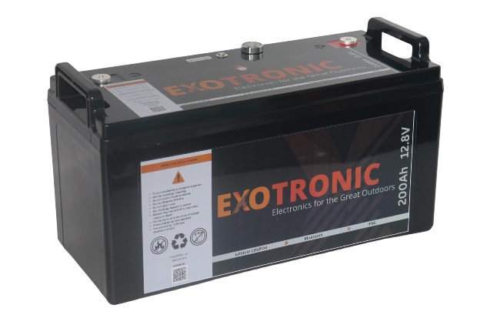
Notes & Limitations
- The State of Charge monitor cannot read current below ~1A and can drift out after several weeks of no use. Complete a full charge cycle to re-calibrate.
- After a trip, either press the On/Off/Reset Button twice to reset, or connect to a suitable power supply or charger to restart the BMS.
- After long periods of no use, or if continuously fast charging, the cells may get out of balance. The active balancer will correct this issue, to allow the balancer time to work, trickle/slow charge the battery to 14.2-14.4V and allow to hold that voltage until balanced.
- Charge at least once every 3 months.
- If the battery trips on low voltage, and is left unattended for several weeks, the cells will continue to drop voltage and the battery may become unrecoverable – the battery must be charged within 72 hours after a low voltage trip.
- To extend the service life, it is recommened to use the battery between 10 and 90% State of Charge.
- Over-current trips will automatically reset after 30s.

Warning
To maximise the longevity and safety of your new lithium batteries, please ensure you follow stay within the specified parameters. Ensure terminals are torqued and bolts are not bottomed out. Failure to do so could result in shortened lifespan and void your warranty.

Risk of Fire / Explosion
- do not short circuit the battery or allow excess dust/moisture between terminals
- Always check polarity before powering equipment on
- Do not expose to direct sun light or sea water
- Do not install near heat sources
- Always fuse the output positive of the battery with a fuse no greater than 2C

Before connection/disconnection, turn off the battery via the On/Off/Reset button Button position - up

Smart Bluetooth
Use the app to check the real-time status of the battery data

On / Off / Reset Button
- Don’t have a dark-start charger handy? Just press the reset button twice to reset.
- Avoid the need of an
isolation switch by simply turning off at the button

Pre-trip Alarm
The battery will provide an audible/visual alarm for 60s at approximately 10% state of charge

Water / Dustproof
IP66 provide protection against high pressure water and complete dust protection thanks to the machine sealing of the battery

Safe and Reliable
- JBD BMS with full protections
- Prismatic aluminium cased GFB cells with rupture vent
- Vibration tested
© Exotronic 2023

Specifications

Battery Capacity | 100Ah | 200Ah
Battery Nominal Voltage | 12.8V
Continuous Current | 100A | 200A
Peak Current (1s) | 170A | 310A
Trip Current (10s) | 110A | 220A
Maximum Inverter Size | 1000W | 2000W
Maximum Number of Parallel Batteries  Must be wired as per Figure 1 | 4 of the same model  No longer than 12 months difference in age
Maximum Number of Series Batteries  Must be wired as per Figure 2 | 4 of the same model  No longer than 12 months difference in age
Low Voltage Trip | 10V
High Voltage Trip | 14.6V
Balance Current | 1.2A
Length  Width  Height | 330mm  175mm  225mm | 363mm  190mm  243mm
Weight | 12.4kg | 20.2kg
Mounting Orientation | Upright
Nominal Continuous Charge Current | 30A | 60A
Maximum Continuous Charge Current | 50A | 100A
Absorption Voltage | 14.0 - 14.2V
Float Voltage | 13.5V
Cycle Life (0.3C) | >3000 100% cycles at 25C  to 70% Capacity within 5 years
Case Material | ABS
Terminal | M8 Bolt - 10mm depth
Terminal Torque | 14Nm Max (12Nm Recommended)
Capacity Measurement | 14.6V to 10V at 0.3C at 25C
Operating Temperature Charging  Operating Temperature Discharging  Operating Temperature Storage | 5C – 45C  -20C – 55C  -20C – 60C
Ideal Storage Conditions | 25C, 40% SoC (approx. 13V)
Battery Ventilation Required | 10mm Clearance on all sides
Caution
- To be installed by a competent person
- Not for cranking / starting
- Do not dispose of in fire
- Do not open case
- Do not drop, impact or pierce

© Exotronic 2023

© Exotronic 2023
Figure 1 – Parallel Wiring

Wiring Notes

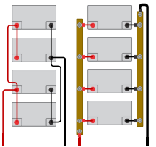
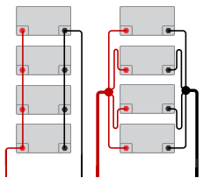

It is essential that all loads and chargers from the batteries evenly distribute current through the batteries, otherwise the batteries will not wear evenly, and excessive differences may cause a battery to fail under heavy loads, such as a large inverter loading one battery most. If using an inverter or charger greater than a single battery is rated for, it is recommended that a third battery is installed, reducing the risk of a cascading failure mode.

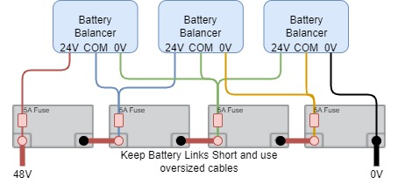

Figure 2 – Series Wiring

NEVER wire ANY loads from the 12V, 24V or 36V terminals, if other voltages are required, you must use a converter, i.e. a 48/36, 48/24 or 48/12 converter across the string of batteries.
Battery balancers serve two purposes:
- Keep batteries balanced: Each two sets of batteries will be monitored and if a voltage difference appears, the balancer will move the charge from one battery to the other
- Alarm if out of balance: If the voltage difference is too great, battery balancers will make an audible alarm to allow you to intervene before damage to the batteries occurs.

